MATRIX (written test 1 – English 6 – school year : 2018-2019)

THEMES | CONTENTS | LEVEL |  |  |  |  |  |  |  | TOTAL |  | RATES
THEMES | CONTENTS | Knowledge |  | Comprehension |  | Application |  | High application |  | Sentences  & scores |  | RATES
THEMES | CONTENTS | Multiple  choice | Writing | Multiple choice | Writing | Multiple  choice | Writing | Multiple choice | Writing |  |  | RATES
Listening 1  Listening 2 | Choose pictures  Choose numbers | 4(1)  4(1) |  |  |  |  |  |  |  | 8 | 2 | 20%
Lexico-  grammar | Phonetics :1  Possessive pronoun:1  Tobe : 2  Question word: 2  Prep : 1  Number : 1  Questions & answers: 4 | 1  1  1  1  (1) |  | 1  1  1  1  4  (2) |  |  |  |  |  | 12 | 3.0 | 30%
Reading 1  Reading 2 | Lexico-close  Comprehension |  |  | 6 (1.5) | 2 (0.5) |  | 2 (0.5) |  |  | 10 | 2.5 | 25%
Writing 1  Writing 2 | Word arrangement  Answer |  |  |  |  |  | 3 (1.5) |  | 2 (1) | 5 | 2.5 | 25%
Total  number |  | 12 |  | 14 | 2 |  | 5 |  | 2 | 35 | 10 | 100%
Total  weight |  | 30% |  | 40% |  | 20% |  | 10%

PHÒNG GD – ĐT CƯKUIN
TRƯỜNG THCS GIANG SƠN WRITTEN TEST 1 - ENGLISH 6
School year: 2018-2019 Time : 45 minutes.
Full name: ………………………..  Class :6… | Mark | Remark

Part A. Listening (2 ms)
I. Part 1. Listen twice and choose the correct picture according to what you hear by circling A, B or C. (1m) (Nghe 2 lần và chọn bức tranh đúng mà em nghe bằng cách khoanh tròn A, B, hoặc C)
1. A. B. C.




2. A. B. C.
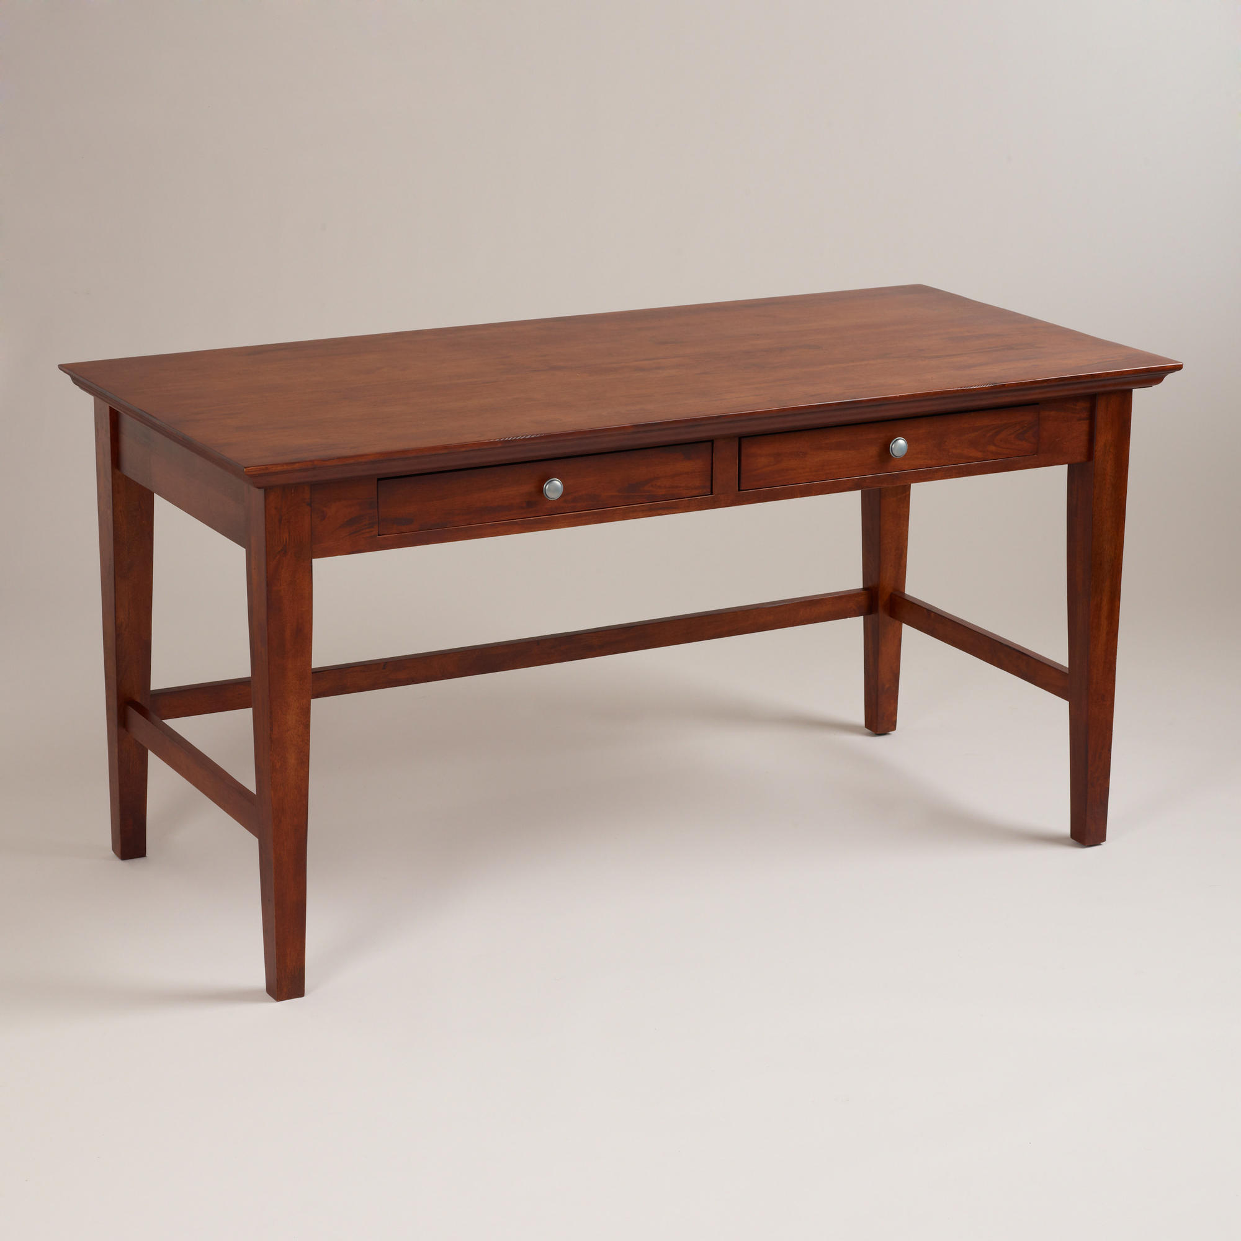



3. A. B. C.
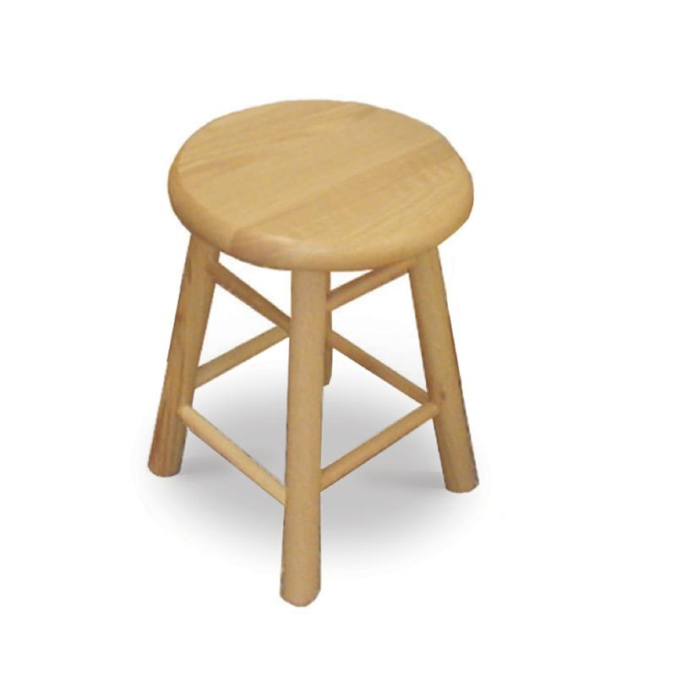

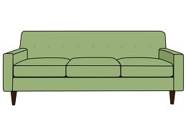

4. A. B. C.


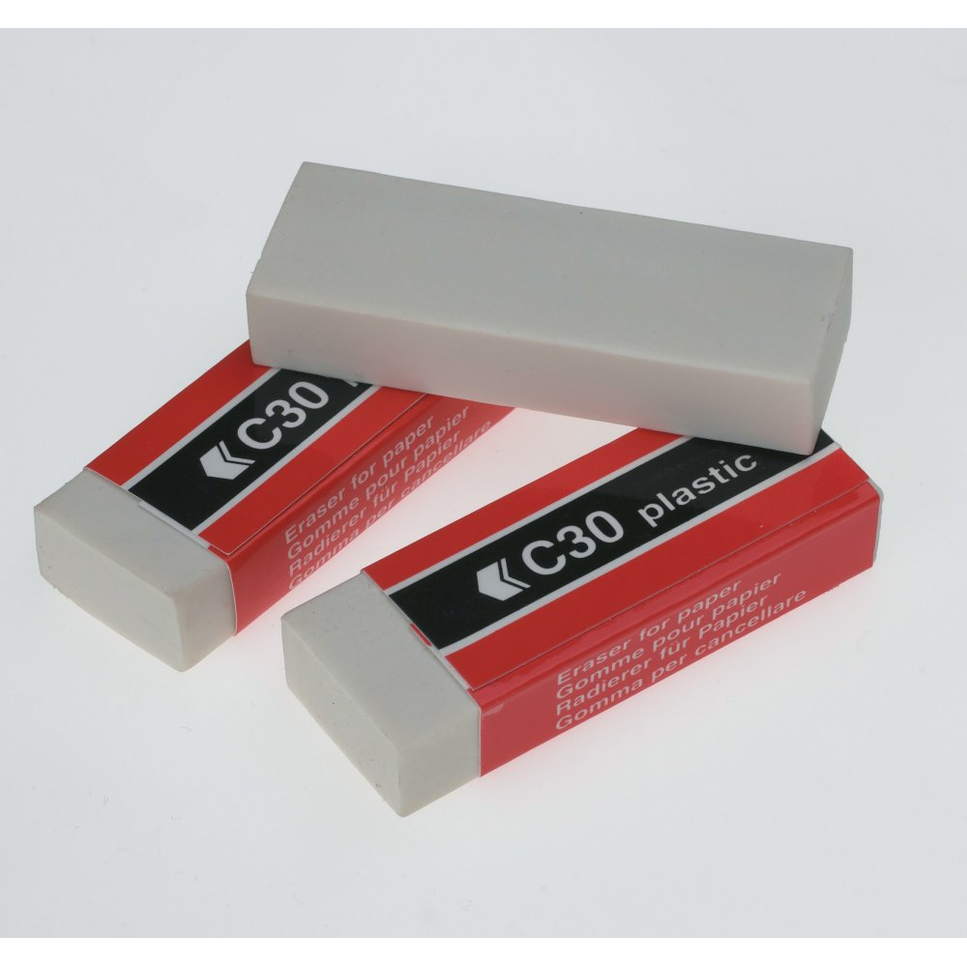

II. Part 2. Listen twice and circle four numbers you hear. (1m). (Nghe 2 lần và khoanh tròn vào 4 số em nghe).
12 20 83 29 97 67
Part B. Lexico - grammar (3ms)
I. Choose the best answer (2ms). (Khoanh tròn vào đáp án đúng)
1. Choose the underlined word that has different pronunciation
A. city B.window C. nine D. live
2.What is your name? - ……………..name is Nga.
A. My B. His C. Her D. Your
3. How ……………………………. you? – I’m fine, thanks.
A. be B. am C. is D. are
4.…………………………….. do you live? – I live on Le Loi street.
A. What B. How many C. Where D. How
5. My name ……………………………… Lan
A. are B. am C. be D. is
6.…………windows are there? – There are four.
A. How many B. What C. How D. Where
7. Come in and sit ……………. , please !
A. in B. up C. down D. on
8. forty + sixty = ......................
A. one hundred B. ninety C. eighty D. seven

II.Match questions in A with their answers in B(1m)(nối câu hỏi ở cột A với câu trả lời ở cột B)
A | B
1, What is this?  2, How do you spell your name ?  3, How old are you?  4, What’s your name? | a, My name is Lan Anh  b, I’m fine, thank you  c, This is a board  d, N-A-M, Nam.  e, I’m twelve years old

1- | 2- | 3- | 4-
Part C. Reading (2.5ms)
I . Choose the suitable words to complete the text (1.5 ms). (khoanh tròn vào từ thích hợp để điền vào chỗ trống)
Nam (1)…….. a student. He is twelve (2)………. old. His father is a doctor. He is forty years old. His mother is a teacher. (3)……… is thirty six years old. His brother is (4) ……engineer. (5)…….. is twenty years old. (6)……. sister is a student. She is fifteen.
1. A. is B. are C. am D. a
2. A. pens B.years C. windows D. doors
3. A. You B. I C. He D. She
4. A. a B. the C. an D. 
5. A. You B. He C. I D. She
6. A. He B. Her C. She D. His
II. Read and do the following tasks (1m).
He is Ba. This is his family. They are in the living room. There are five people in his family: his grandfather, his father , his mother, his sister and Ba. His grandfather is 75 years old. This is his father. He is fifty – three. He is a doctor. This is his mother. She is forty - nine . She is a nurse. His sister is a student in Luong The Vinh secondary school.
Answer the questions (0.5m) (trả lời câu hỏi)
1. How many people are there in his family ?
→...........................................................................................................
2. How old is his father ?
→.......................................................................................................................
Complete Ba’s family tree (0.5m)
grandfather
(hoàn thành thông tin
về gia đình Ba)
(3) …………..
father

(4)…………..
Ba

Part D. Writing (2.5ms)
I.Rearrange these words to make complete sentences. (1.5 ms) (sắp xếp từ thành câu đúng)
1. books/ How/ there/ are/ many / ?
→.........................................................................................................................................
2. is / eleven / old / She / years /. →.....................................................................................................................................
3. my /is/ family/ This.
→.........................................................................................................................................
II. Answer about you. (1m). (trả lời về chính mình)
1.What’s your name ?
→
2.How old are you ?
→

PHÒNG GD – ĐT CƯKUIN ANSWER
TRƯỜNG THCS GIANG SƠN WRITTEN TEST 1 - ENGLISH 6
School year: 2018-2019 Time : 45 minutes.

Part A.Listening (2 ms)
I. Part 1. Listen twice and choose the correct picture according to what you hear by circling A, B or C. (1m) (Nghe 2 lần và chọn bức tranh đúng mà em nghe bằng cách khoanh tròn A, B, or C)
1. A 2.C 3. B 4. A
II. Part 2. Listen twice and circle four numbers you hear. (1m). (Nghe 2 lần và khoanh tròn vào 4 số em nghe).
12 20 29 67
Part B. Lexico - grammar (3ms)
I. Choose the best answer (2ms). (Khoanh tròn vào đáp án đúng)
1. C 2. A 3. A 4. C
5. D 6. A 7. C 8. A
II. Match questions in A with their answers in B (1m)
(nối câu hỏi ở cột A với câu trả lời ở cột B)
- c 2. d 3. e 4. a
Part C. Reading (2.5ms)
I . Choose the suitable words to complete the text (1m). (khoanh tròn vào từ thích hợp để điền vào chỗ trống)
- A 2. B 3. D 4. C 5. B 6. D
II. Read and do the following tasks (1m)
Answer the questions (0.5m) (trả lời câu hỏi)
- There are five people in his family
- He is fifty – three
Complete Ba’s family tree (0.5m)(hoàn thành thông tin về gia đình Ba)
- mother
- sister
Part D. Writing (2.5ms)
I.Rearrange these words to make complete sentences. (1.5 ms) (sắp xếp từ thành câu đúng)
1. How many books are there?
2. She is eleven years old.
3. This is my family.
II. Answer about you. (1m). (trả lời về chính mình)
- My name’s…………..
- I’m ……………………….

